**Ideation Phase**

**Empathize & Discover**

|  |  |
| --- | --- |
| Date | 25Janu2025 |
| Team ID | Team ID: LTVIP2025TMID31490 |
| Project Name | HealthAI: intelligent healthcare assistant |
| Maximum Marks | 4 Marks |

**Empathy Map Canvas:**

Here's a clear and simple Empathy Map Canvas for an Intelligent Healthcare Assistant user (e.g., a patient or caregiver). This tool helps understand the user’s mindset and guide design decisions.

---

🧠 Empathy Map Canvas: Healthcare Assistant User (Patient)

Section Details

🗣 Says “I feel sick, but I can’t get a doctor’s appointment.”<br>“I forget my medications.”

🧏 Thinks “What if my condition worsens?”<br>“I wish there was someone to remind me.”

👀 Sees Long queues at hospitals<br>Confusing health apps<br>Limited rural facilities

👂 Hears “You should monitor your blood pressure daily.”<br>“You missed another checkup.”

💬 Does Uses smartphone occasionally<br>Misses medications<br>Searches symptoms online

😟 Feels Worried about health<br>Overwhelmed by technology<br>Lonely or unsupported

🎯 Pain Points No immediate doctor access<br>Forgetfulness<br>Complex healthcare systems

🌟 Gains/Needs Easy-to-use assistant<br>Reliable health advice<br>Medication &

appointment reminde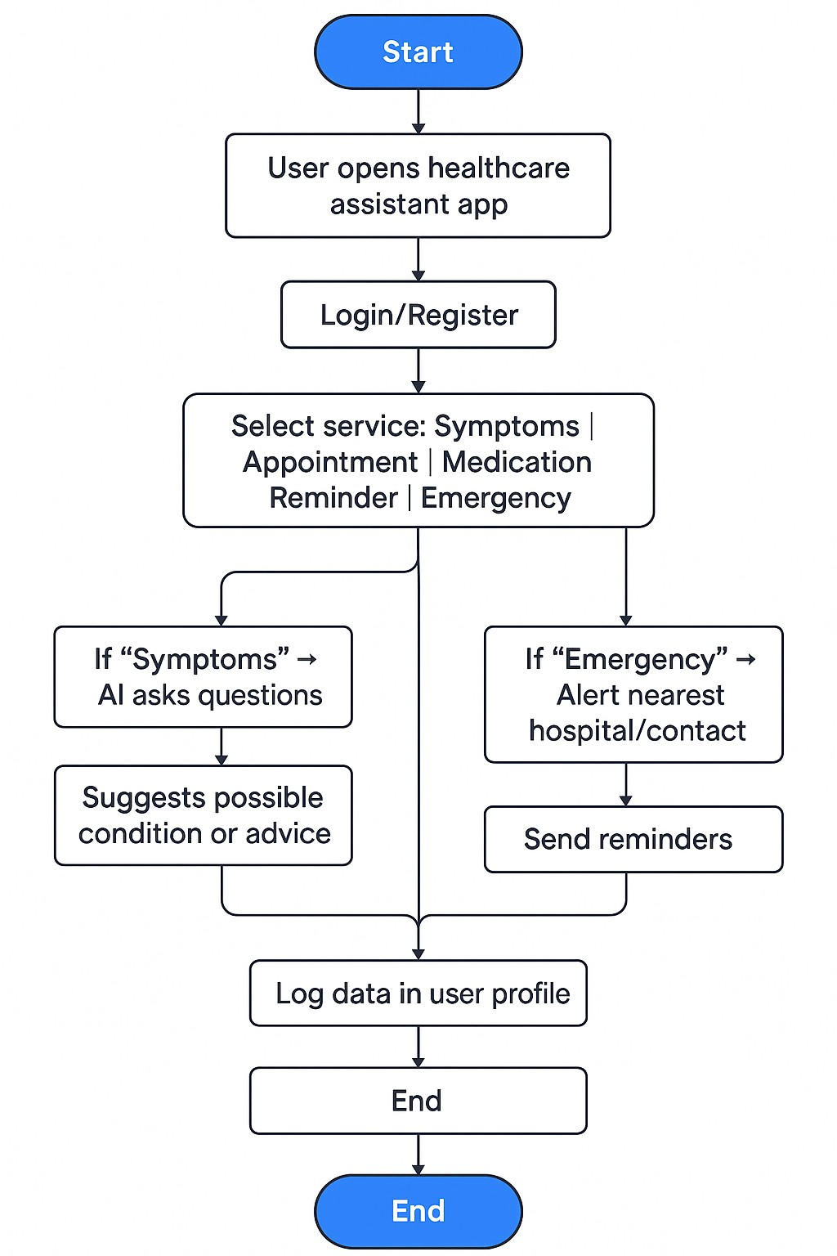

Reference: <https://www.mural.co/templates/empathy-map-canvas>

# Example: healthcare assistant and patient

